
FAITH COMMUNITY NUTRITION DIALOQUE

The role of the church and faith-based organizations in Ending Child Hung and Malnutrition in South Sudan

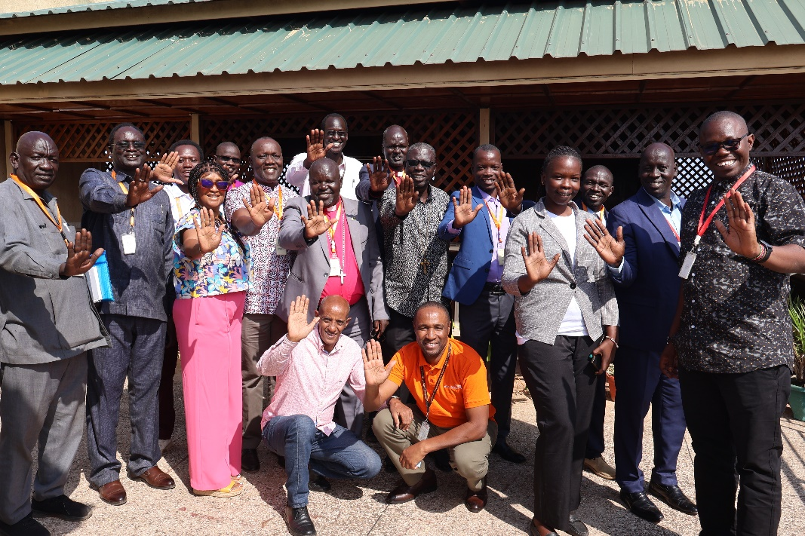

28TH November 2024
@ World Vision South Sudan, Rooftop Hall

Participants: 15 Church and FBOs leaders (see Annex)

- INTRODCUTION

  - Opening prayer and Reflection by Dr Sam Onapa,

Scripture: Matthew 22:33-40 (NIV)
³³ When the crowds heard this, they were astonished at his teaching.

The Greatest Commandment
³⁴ Hearing that Jesus had silenced the Sadducees, the Pharisees got together. ³⁵ One of them, an expert in the law, tested him with this question: ³⁶ “Teacher, which is the greatest commandment in the Law?”
³⁷ Jesus replied: “‘Love the Lord your God with all your heart and with all your soul and with all your mind.’^{[a]} ³⁸ This is the first and greatest commandment. ³⁹ And the second is like it: ‘Love your neighbor as yourself.’^{[b]} ⁴⁰ All the Law and the Prophets hang on these two

Emphasis were laid on the following, that:
We, as the Church of God, represent a Nation/Kingdom of God. We are descendants of Abraham through our faith in Jesus (Galatians 3:7-8).
- Empowered to Act: We have been given keys, and with these keys, we can stop child hunger and other vulnerabilities.
- Guided by the Bible: Our constitution, the Bible, contains values that challenge unprogressive and negative cultural norms.
- Moral and Legal Responsibilities: We have the duty to end the vices that perpetuate child hunger and malnutrition.
- Welcoming Children: As stated in Mark 9:36-37, "Whoever welcomes one of these little children in my name welcomes me; and whoever welcomes me does not welcome me but the one who sent me." Let us embrace child concerns in our communities.
- Providing for Our Own: We must be able to provide for our households, as failing to do so makes us worse than unbelievers.
- Advocating for Kingdom Values: With the enormous power given to us as a nation, we have the moral authority to advocate for the values that represent the Kingdom of God. We are the Church in South Sudan, not just a church of South Sudan.

  - Opening Remarks by Country Programme Director:
The Operations Director welcomed that participants and appreciated them for turning up for the dialogue. Dorance led introductions and welcome the CD to give the opening remarks
The country Program Directors remarks:
  - Appreciation of Leaders' Participation: All church and FBO leaders were appreciated for their attendance and participation in the FCN dialogue.
  - Emphasis on WVI Mission: The mission of World Vision International (WVI) in South Sudan was emphasized.
  - Acknowledgment of Long-term Collaboration: Recognition of WVI's long-standing collaboration with the Church and Faith-Based Organizations (FBOs). Examples cited include the Hope Initiative, implemented through Channels of Hope, addressing HIV, Ebola, COVID-19, and other critical campaigns.
  - Role of the Church in South Sudan: Highlighted the Church's pivotal role in mobilizing children, families, and communities towards positive and impactful causes.
  - South Sudan is blessed to work with the Church in these efforts.
  - Invitation to Partnership: The Church and Faith-Based Organizations were welcomed to partner in the ENOUGH initiative and other endeavors in South Sudan.
- OVERVIEW OF NUTRITION, FCND AND ENOUGH
  - Nutrition:
Summary of Malnutrition facts in South Sudan:
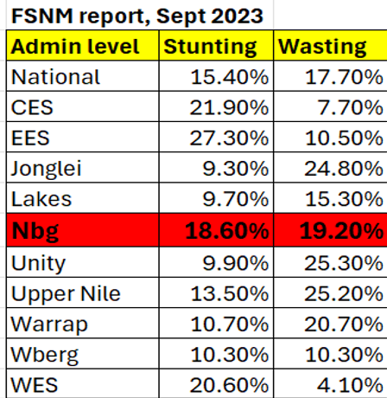
- Children and women in South Sudan continue to suffer from unacceptably high levels of malnutrition with GAM levels remaining above the WHO emergency threshold of 15%.
- 5.8 million people being food insecure.
- 46/80 (58%) counties have GAM rates above 15%.
- Only 5% children getting the minimum acceptable diet.
- 1.65 million children between 6-59 months are malnourished including 480,000 with SAM, 1.17 million with MAM.
- 870,000 pregnant or breastfeeding women have acute malnutrition
- An estimated 72 percent of the acute malnutrition burden is concentrated in the five states of Jonglei, Northern Bahr el Ghazal, Upper Nile, Unity and Warrap.

In summary South Sudan is not doing well across the country as shown below and would be good for the churches to identify where they are and could provide help: based on IPC …………..
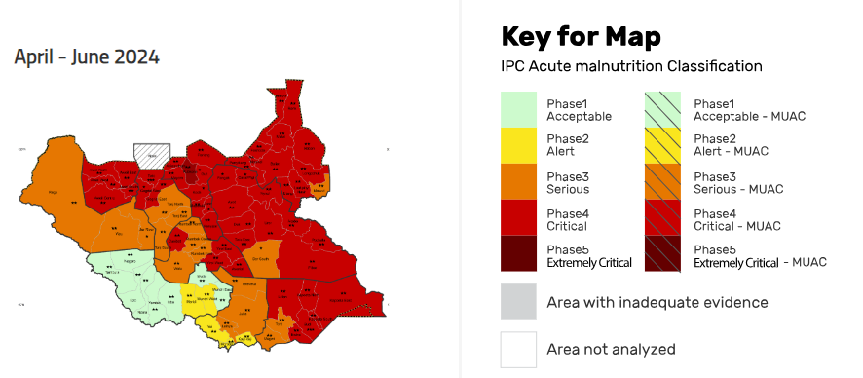

The main drivers of malnutrition: Poor Feeding, Poor Care, Poor hygiene, poor Healthcare
Solutions: Proper feeding, Proper Care, Proper Hygiene, and Proper Healthcare
Nb: Find details a separate PPT

  - Overview of Faith Community Nutrition Dialogue:
Reiterated that the theme was: Theme: The Role of the Church and Faith-Based Organizations in Ending Child Hunger and Malnutrition
The participants were facilitated to understand the purpose FCND in relation to the deliberations of Nutrition for Growth (N4G) Summit of March 2025​
- At N4G world leaders come together to increase their response, raising the importance of nutrition as critical for realizing the Sustainable Development Goals. ​
- Nutrition Dialogue program supported by World Vision International and 4SD Foundation ​
- Bring the perspectives and lived experience of people from communities at risk of malnutrition to the leaders attending the N4G Summit.
- Engage nutrition stakeholders such as faith leaders primarily at national and community level, to share perspectives and explore priorities for actions to improve nutrition within their own localities​
And these expectations were to:
- Create Platforms for Dialogue​
- Collaboration with Faith Actors
- Promote Accountability and Transparency ​
- Promote Behaviour Change and Healthy Practices​
- Advocate for Food Security and Nutrition Justice​
These were emphasized through sharing of the:
- Theological basis,
- Importance of Hearing from Faith Communities in Nutrition Dialogues​
- F&D Voice in Nutrition dialogues
Nb: More details on a separate PPT
  - Overview of enough:
Participants were introduced to ENOUGH Campaign Overview encompassing: The Purpose and the then ongoing engagements; the Vision, Strategic Goals, Outcomes and Expected Results; the Framework on what Enough Means to South Sudan and the strategic avenues to advancing it.
Nb: More details on a separate PPT

GROUP DISCUSSION:
The participants took time to discuss critical questions and made recommendations from the Faith Perspective:
- What are the key nutritional problems in South Sudan? And what can be done from faith perspective (5 points or more)
- More than 1.6m children under five are expected to suffer from malnutrition in South Sudan in 2024. What is the role of the churches and faith-based organizations in ending child hunger and malnutrition in South Sudan? (10 points and more)
- What are your recommendations to the partners, the donors’ community and the world leaders (5 Recommendations)

Results of the discussions presented in a plenary:
Qtn 1; What are the key nutritional problems in South Sudan? And what can be done from faith perspective (5 points or more)
Nutritional underlying problems and faith-based solutions;
Key Nutritional Problems in South Sudan | Faith-Based Solutions
- Flooding Affecting Farmlands | - Raise awareness and sensitize communities on disaster risks and how to mitigate; pss information in tiem
- Insecurity | - The Church should advocate for social justice and national reconciliation and healing.
- National Reconciliation and Healing | - Churches and FBOs should advocate for socio-economic justice.  - Create awareness within families  - Promote peacebuilding among different communities.
- Cultural Values | - Prioritize children's nutrition over adults.  - Encourage both men and women to actively participate in farming and providing for the family  - Address the attitude of idleness by promoting a culture of work.  - Use biblical teachings to change mindsets (e.g., Romans 12:2, 2 Thessalonians 3:10, 1 Timothy 5:8).
- High level Poverty and Limited Resources | - Change attitudes by encouraging a culture of work, such as church farms.  - Churches and FBOs should collaborate to provide vocational training (e.g., tailoring, bricklaying).  - Mobilize local resources.
- Poor Health | - Strengthen local health facilities to offer nutrition services in communities and enable many communicates to access them
- Poor Socio-Economic Status and Low-Level Education and lack of political will | - Advocate for the diversification of natural resources and agricultural allocations  - Promote policy advocacy for equality and equity in government support and resource distribution regardless of political affiliations or geography
- Poor Feeding Practices | - Advocate for farming and good nutrition awareness.  - Integrate these messages into sermons and empower church workers to promote these practices.
NB: More solutions have been provided in the recommendation’s sections below

Qtn 2; More than 1.6m children under five are expected to suffer from malnutrition in South Sudan in 2024. What is the role of the churches and faith-based organizations in ending child hunger and malnutrition in South Sudan? (10 points and more).
Role of the church and faith-based organizations in ending child hunger and malnutrition
Key Recommendation | Details
- Enhance Agricultural Support and Partnerships | - Bring in agricultural experts and enhance partnerships with stakeholders to support agriculture as a foundational economic activity.  - Engage the government to support agriculture through its institutions.
- Establish and Support Feeding Centers | - Build on existing feeding centers, such as those in Mangala Diocese, to address hunger and malnutrition.  - Coordinate with donors and churches for effective service delivery in areas prone to hunger.
- Promote Civic Education and Address Malnutrition | - Support churches in providing civic education to end hunger and child malnutrition.  - Advocate for sustainable livelihood programs to transition from emergency aid to long-term solutions.
- Strengthen Peacebuilding and Security Efforts | - Advocate for the implementation of peacebuilding initiatives and support the government in stabilizing security.  - Provide resources for peacebuilding and community transformation initiatives.
- Foster Government and Church Collaboration | - Lobby the government to work with churches and faith-based organizations (FBOs) to address the root causes of conflicts.  - Engage influential world leaders to pressure the government to commit to ending conflicts.
- Support Governance and Institutional Development | - Assist in building and establishing institutions of governance in South Sudan.  - Promote inter-communal dialogue to foster peace at the grassroots level, especially regarding land use to avoid conflicts.
- Advocate for Regional and Cross-Border Peace | - Encourage the church to advocate for regional peace, complementing the work of the National Council of Churches.  - Unite various church representatives in committees to work towards peace, regardless of denomination and geography.

Qtn 3; What are your recommendations to the partners, the donors’ community and the world leaders (5 Recommendations)

These following highlights the multiple approaches that the church and faith-based organizations recommended to take to address child hunger and malnutrition in South Sudan.

Role of the Church and Faith-Based Organizations | Description
- Encouraging Large-Scale Agriculture | - Promote and support large-scale agricultural initiatives to increase food production.
- Coordinating Agricultural Tools and Implementation | - Work with partners to provide necessary agricultural tools and resources to communities.
- Community Engagement in Food Production | - Mobilize community members to actively participate in food production activities.
- Establishing and Supporting Feeding Centers | - Set up and maintain feeding centers to ensure children receive nutritious meals.
- Sensitizing on Good Hygiene Practices | - Educate Christians on the importance of good hygiene to prevent malnutrition-related diseases.
- Supporting Vulnerable Populations | - Provide assistance to vulnerable groups, including children, the elderly, people with disabilities, orphans, widows, and women.
- Advocating for Socio-Economic Justice | - Take a leading role in advocating for socio-economic justice and national reconciliation to create a stable environment for food security.
- Transforming Cultural Values | - Use biblical teachings to transform negative cultural values into positive ones that support community well-being.
- Imparting Vocational Skills | - Offer vocational training to community members to help them increase household income and improve food security.
- Educating Through Sermons | - Incorporate teachings on food production and nutrition into sermons to educate the faithful on how to apply these practices in their daily lives.

Miscellaneous additional remarks from participants on the way forward regarding the church and FBOS effort to address hunger and malnutrition;
- The churches should consider subscribing to the National Council of Churches or another umbrella structure to form a credible collaborative force. This could enhance their collective impact and address common challenges like hunger and malnutrition in South Sudan more effectively.
- Promote cross and regional learning exchange: Some churches have established a farm and purchased machinery to start agricultural activities, aiming to produce and sustain production. They need minimal support to identify the right nutritional seed varieties to ensure success, and others can learn from their example.
- The church's role is vital and must be recognized by both support agencies and the government, especially in addressing border issues in Congo, Central Africa, and Sudan. The church's efforts should be complemented and supported to continue their impactful work. Engaging with national leaders to help them understand the values of righteousness and justice is crucial for South Sudan as a nation.
- The church should seek involvement in the constitutional process to ensure that values of right and wrong are reflected in the nation's constitution. This involvement is essential for the church to influence the constitution effectively. Recognizing the church's ongoing contributions and allowing them to continue their work is vital for the nation's progress and peace.

Concluding Remarks
The operation directors concluding remarks
- Emphasized WVI’s Integrated focus (3Cs) – Christ Centeredness, Child focus and Community Empowerment.
- Assured the Church leaders and FBOs participants that WVI will get back to them after consolidating the recommendations and to also explore better ways to work together
- All participants were appreciated for their time
- Concluding prayer was offered by Pr. Thomas Amoli

ANNEX
28 November 2024 | World Vision International, Juba, South Sudan

Activities | Time Allocated | Presenter
Programmer |  | Moses Philip
Welcome and Introduction of FCND stakeholders | 9:00 – 9:10 am | Dorance Cooper
Opening Prayer and Bible Reflection | 9: 11 -9: 25 am | Dr Sam Onapa
Opening remarks from CD | 9:26 - 9:30 am | Dr. Mesfin Loha
South Sudan Nutrition Situation | 9:31 – 9:40 am | Stephen Epiu
Role of Faith leaders in FCND | 9:41 – 9: 50 am | Pr. Lam Duop
Enough Campaign | 9: 51 - 10: 00 am | Ronald Ngetich
Group discussion and Feedback (40 Mins)  - Sharing and Reflection (30 mins)  - Synthesis and Way Forward (20 mins) | 10: 01 – 11: 30 am | Moses, Ronald
Closing remarks | 11: 31 – 11: 35 am | Dr. Mesfin Loha
Closing prayer | 11: 36 – 11: 40 am | Pr. Thomas Amoli
Tea, snack and refreshments | 11: 41—11:55 am | Moses Philip
Departure | 11: 56 am | All

Participants; 15
Report by: Pastor Lam Duop Lam
WVSS Faith and Development Coordinator

