DIALOGUE TITLE | Successes and challenges of Food insecurity in MAPIKO APs
DIALOGUE DATE | 5, 11 & 12, Dec 2024
CONVENED BY | The Enough -campaign
HOST LOCATION | MAPIKO APs, Lesotho
GEOGRAPHIC SCOPE | AP Community

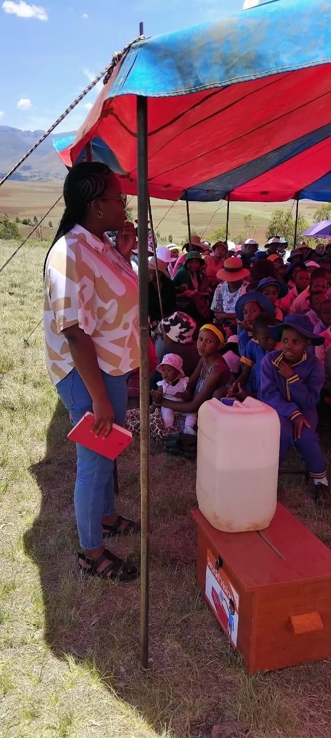
THE OBJECTIVE OF THE DIALOGUES WAS TO GATHER:
- The factors contributing to high poverty and food insecurity in Lesotho
- The strategies Lesotho could employ to fight food insecurity and child malnutrition, and
- The challenges facing Lesotho in fighting food insecurity, hunger and malnutrition

TOTAL NUMBER OF PARTICIPANTS | 159

PARTICIPATION BY AGE RANGE
159 | 2, 7, 10,15-18 of age children  adults 18-60 years

PARTICIPATION BY GENDER
107 | Female | 52 | Male | 0

TYPE OF PARTICIPANTS

The participants were children, facilitators and community, they came from different areas of APs with different climate some are in the foothills while others are from lowlands. The weather conditions are very different, some plant very early to minimize early frost while others in the normal time. They have a different age group. Some were farmers

The dialogues began with sharing the objectives of the dialogues.
The dialogues were guided by a nutrition tool. The guiding questions on the tool were actually the objectives mentioned above which are the factors contributing to high poverty and food insecurity in Lesotho, the strategies Lesotho could employ to fight food insecurity and child malnutrition as well as the challenges facing Lesotho in fighting food insecurity, hunger and malnutrition.

DISCUSSION ON THE OBJECTIVES
The group discussed: The factors contributing to high poverty and food insecurity in Lesotho, group mentioned that, factors are: 1. More people do not have machinery that can help them to work at the field at any time convenient to them. They had to hire and they very expensive where some do not have means as they do not have any sort of subsidy. (Jobless)
2. Off late, rich people practice what we call smart agriculture where there are shadets or green houses that keep crops or vegetable from harsh weather conditions. And definitely the yield became 100% good

On the strategies Lesotho could employ to fight food insecurity and child malnutrition,
1. Big and small farmers be assisted with machinery where they can plant crops and vegetables in abundance and be able to store for future.
2. Water pumps should be drilled in the fields to allow farmers to water crops during dry seasons.
3. Cash crops farmers should be assisted with money to start projects where they can have them annually and this will help them to have a sustainable market, like selling crops to big supermarkets like Pick and Pay Supermarkets.

On the challenges facing Lesotho in fighting food insecurity, hunger and malnutrition,
- Participants mentioned the need for access to manure at any time.
- Government should place Extension Officers all over the country with the resources to allow them to reach all the farmers even in rural or hard to reach areas.
- Farmers should be capacitated on the rotational planting of crops

CHALLENGES
Food insecurity brought negative results in the country especially to children

ACTIONS TO BE TAKEN
Government should put more money to Agriculture as it the backbone in Lesotho, to capacitated farmers on the smart agriculture. If the country had enough food, there will be no malnutrition and other diseases coursed by food insecurity as well as child marriage as some findings revealed children get married because of poverty in their respective homes. And non-governmental organizations also should direct most of the funds to agriculture since the government had declared EL-Nino. There is a serious food insecurity in the country.

OVERALL SUMMARY
The discussion was done in a group form after the launching of a campaign where children choose one to lead the discussion, they went very well, points were raised on the strategies Lesotho can adopt to eradicate poverty or food insecurity that affect children negatively. Some mentioned that even in the supermarket’s, food prices had to be lower to allow needy people to afford them like fish, eggs, peanut butter, etc. for proper nutrition.

METHOD AND SETTING
Group discussion method

