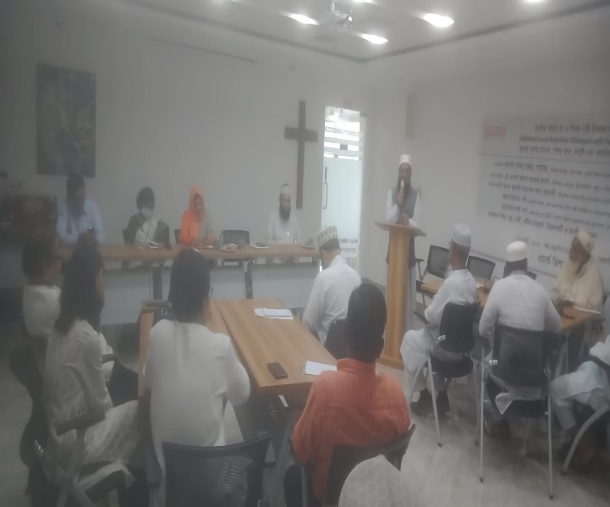
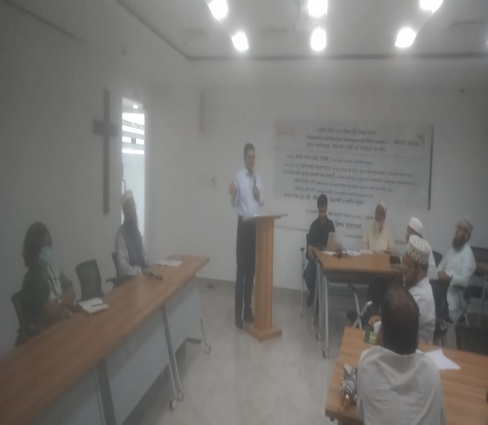

Report on the National Level Nutrition Dialogue of Religious Leaders
4th August 2025, World Vision Bangladesh, National Office.

The National Level Dialogue of Religious Leaders on Nutrition was held at the Shanta Western Tower in Tejgaon, Dhaka. The event was organized by World Vision Bangladesh with a mixed faith group of 77 people including 44 Male, 33 Female; 4 boys and 12 girls, 44 faith leaders and to discuss and strengthen the role of faith leaders in raising nutritional outcomes in the country.
There has been an active involvement of a wide faith-based organizations and leaders. These consisted of the National Council of Churches in Bangladesh, the National Christian Fellowship of Bangladesh, the Catholic Bishops Conference of Bangladesh, the Islamic Foundation, the Bangladesh Imam Association, Good Neighbors Bangladesh and Lutheran Health Care Bangladesh. The fact that the Christian and Muslim faith leaders took part and played an important role in the event highlighted its collaborative and interfaith character.
The discussion started with the part of the registration, and then the warm welcome by Mridul Toju, National Coordinator of Strategy, Innovation, and F&D at World Vision Bangladesh. The initial session was enhanced by scripture readings and prayers by Fr. Ajit V Costa of Catholic Church and Imam and Madrasa Teacher, Md. Siddiqur Rahman of Basabo, Dhaka. It gave the event a collaborative and reflective atmosphere. Mr. Chandan Z. Gomez, Senior Director of Operation at World Vision Bangladesh, delivered the welcome speech and he inaugurated the event by explaining the important goals of the event.
The morning was spent extensively in familiarizing the participants with the contemporary nutritional issues in Bangladesh. Mr. Md. Mizanur Rahman, Senior Manager of Health and Nutrition at World Vision Bangladesh gave an in-depth presentation on the condition of malnutrition, food insecurity and the related hunger in the country which formed a factual basis of further discussions.
The discussion then shifted to its central theme which was the analysis on the question of nutrition in the context of faith. Rev. Martha Das, General Secretary of the National Christian Fellowship of Bangladesh, reflected on hunger and malnutrition from the Christian perspective. She translated religious values to taking practical actions to promote nutrition of mother and children. She urged the need to work together with other religious groups.
Thereafter, Mr. S.M. Usman Gani, an Assistant Professor in the Dhaka Ahsania Mission Institute of Sufism, and Assistant General Secretary of Bangladesh Imam Association, presented the relevance of the Islamic teachings and ethics in enhancing maternal and child nutrition, and transforming the negative beliefs and practices in the society. Mr. Zubayer Ahmed Al-Azhari of Imam Training Academy of the Islamic foundation discussed on the issue of adolescent health. He discussed the possible importance of religious leaders in this crucial field.
Then, small group discussions and open discussions were mediated by Mr. Mridul Toju. The participants were asked to analyze the religious and cultural issues that positively and negatively contribute to the health of mothers and children. The lessons of these groups were subsequently discussed by way of a plenary presentation. The occasion was enhanced by the participation of Dr. Rawshan Jahan Akhter Alo, Director of the Institute of Public Health Nutrition, Ministry of Health and Family Welfare, who was the Chief Guest. She gave a thought-provoking speech. The discussion ended with a prospective meeting on what should be done.
The last closing remarks and vote of thanks was given by Mr. Chandon Z Gomes, with a way forward how the religious leaders can work to promote nutrition efficiently and influence the governments against child marriage and child labor.

Finding Nutrition Conversation with Faith Leaders:
The dialogue led to a finalized report and findings on the role of faith leaders and their challenges in facilitating health and nutrition of mother and children in Bangladesh. Presentations, group, and open discussions and sharing were based on guided questions. The findings are presented in this report are a synthesis of the findings of the National Level Nutrition Dialogue with faith leaders on 4th August 2025 at National Office, World Vision Bangladesh. It answers major questions about the problem of child nutrition, the presence of faith-based organizations and propositions on how to enhance health and well-being in Bangladesh.
Question 1: What are the spiritual and other reasons of poor childcare and feeding habits in Bangladesh?
The problem of poor childcare in Bangladesh is a complex problem based on spirituality and social economic status, as well as the cultural beliefs. Religious people recognize that poor nutrition is caused by the old traditions, which include the disposal of colostrum of the mother, and the ignorance regarding foods that are acceptable as per religious practices. Proactive health actions are also discouraged by fatalistic opinion, in which poverty is regarded as the will of God. These religious aspects are multiplied by poverty that constrains the availability of various foods and gender that makes the childcare burden on women leaving them with less autonomy. Poor knowledge of infant feeding practices is associated with low level of female literacy. Food security is often affected by environmental issues such as flooding, and females and children are usually left vulnerable to food distribution as practices are cultural oriented where male adults are given priority. Poor knowledge, be it religious concessions, cleanliness or contemporary nutrition, is a major obstacle. Families, driven by economic losses, use traditional, and usually not hygienic, forms of care instead of professional medical care; further endangering the health and wellbeing of the children.
Question 2: What can religion leaders and faith-based organizations do to enhance the practice of feeding and caring of children?
Faith-based organizations (FBOs) and religious leaders can play a unique role in enhancing child nutrition because they have a wide presence and impact. The faith leaders propose to use platforms such as Jumuah (Friday) prayers, madrasas, and schools to promote health information. One of the most important strategies, which is proposed by the leaders of faith, is to make right nutrition and hygiene a religious obligation and use texts such as the Quran and Hadith to stress the importance of cleanliness and sound practices. The Faith leaders explained that proper feeding can be framed as a moral/spiritual duty and thus increase the rates of breastfeeding with the inclusion of nutrition messages in the sermons. FBOs can run community forums, collaborate with health programs in the government to distribute fortified foods in religious centers, and oppose gender discrimination by promoting equal food distribution according to religious beliefs of equality. Clergy can be culturally aligned and factual by training them on evidence-based nutrition science. This spirituality-meets-health collaborative strategy enables communities to make sustainable behavioral changes to produce improved child outcomes.
Question 3: What are the barriers to religious leaders and faith-based organizations being agents of change to reduce the malnutrition and care practices in Bangladesh?
Faith leaders and FBOs have great barriers in their quest to address malnutrition. The discussion between the faith leaders found a major issue in that they had little knowledge of nutrition and that they lacked awareness in their respective communities. The religious leaders revealed that the strictness of the faith with the conservative interpretations can be incompatible with the current health recommendations. Resource limitation is one of the biggest challenges since funding can be insufficient to expand the programs of the FBOs particularly in remote regions where malnutrition is high. Specific needs of women and children are also overlooked due to gender relations in male religious leadership. More so, another form of resistance is even in community within faiths or social stigma which discourages the participation of the community. Poor infrastructure in disaster prone areas hinders outreach efforts due to the logistical barriers. These challenges can be addressed by specific religious leadership training, interfaith cooperation, or collaboration with health companies that will help the religious entities to achieve credibility and get the required resources to implement effective interventions.
Question 4: How could religious leaders and faith-based organizations collaborate towards the betterment of health and general wellbeing of children in Bangladesh?
There are enormous possibilities in enhancing the health of children in Bangladesh by the faith leaders and FBOs. The discussions put a lot of weight on the possibility of utilizing religious meetings to create awareness among the people regarding health and nutrition. The leaders of faith view themselves as teachers, who impart important knowledge regarding food and hygiene. The faith leaders proposed that faith networks would be capable of accessing underserved communities with existing gaps in services provided by the government. Certain opportunities that can be utilized are linking with national health programs like involving mosques as vaccination points during immunization exercise. FBOs can be also very important in maternal and child health because they can offer faith-related counseling on how to take care of a baby during the pregnancy. They are able to dispense useful micronutrients during disaster response. Through interfaith dialogues, leaders will be able to support the rights of children and shape national policies. The online platforms will provide a new way of educating leaders on new challenges such as mental health. With the efforts aligned with the national and international development objectives, FBOs can find funding and expand successful, evidence-based interventions.
Question 5: As a representative of religious leaders, what do you recommend the overall and sustainable development of health and well-being in Bangladesh?
The religious leaders have offered a holistic list of prescriptions of sustainable health enhancements. The discussion of the faith leaders was based on practical, immediate issues of food safety by keeping it unadulterated, preventing food poisoning, and avoiding hoarding and price-fixing syndicates. They also suggested the abandonment of selling immature produce. The religious leaders demanded that health education be integrated into the religious teachings using faith-sensitive curricula that are developed in partnership with the health organizations. The policy changes that were being demanded included the provision of more funds towards rural health services and the introduction of community health committees in places of worship where child development was to be checked. The recommendations also include promoting gender equality, using technology to spread awareness, interfaith collaborations to discuss such areas as climate change, and investing in youth programs.
In summary, it was one of several events taking place globally to reach out to faith leaders, as a build-up to the Catholic Jubilee that will take place in October 2025. We would like to express our special thanks to Desmond Lim, Regional F&D Advisor at SAPO and the Global F&D Leaders. Their immeasurable financial assistance and technical expertise have helped this initiative to be successful.

By
Mridul Toju
National Coordinator
Strategy, Innovation, Faith & Development
World Vision Bangladesh
Date: 13 Sept 2024
Few Picture of the event:
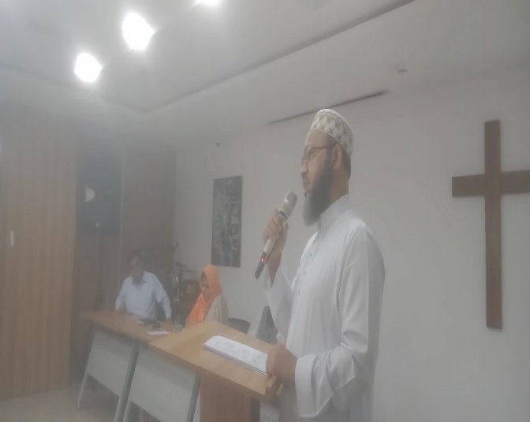
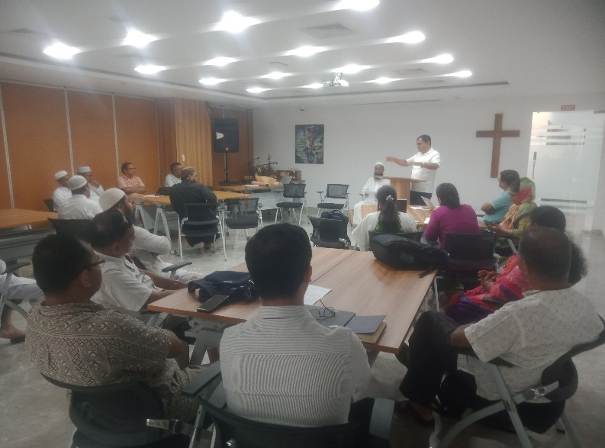
Welcome Speech and Inauguration of the event by Chandan Z Gomes, Sr. Director, Operations, WV Bangladesh at the Nutrition Dialogue with Faith Leaders on 4th August 2025, National Office, WVB

Participant of Nutrition Dialogue with Faith Leaders on 4th August 2025, National Office, WVB

